Experiment 9

Aim: - To implement ARP protocol using UDP protocol.

Steps for server: -

1. We import socket module which helps in establishing the client/server communication. Import Sub process.
2. Get the hostname using gethostname() function.
3. Get the data from the client using recvfrom() function with max 1024 bytes.
4. We decode the data received and get the logical address and mac address using run() function under the subprocess package.

Steps for Client: -

1. We import socket module which helps in establishing the client/server communication. Import Sub process.
2. Get the hostname using gethostname() function.
3. We convert the hostname into the ip using gethostbyname().
4. We enter the IP address and send it to server to get the mac and Ip.

Code for Server:-

**import** socket  
**import** subprocess  
  
s=socket.socket(socket.AF_INET,socket.SOCK_DGRAM)  
  
host=socket.gethostname()  
port=6969  
s.bind((host,port))  
  
**while True**:  
 print(**"Waiting for Client !"**)  
 data,addr=s.recvfrom(1024)  
 com=**"arp -a"** + str(data.decode())  
 p=subprocess.run(com,capture_output=**True**,shell=**True**)  
 print(p.stdout)

Code for Client:-

**import** socket  
s=socket.socket(socket.AF_INET,socket.SOCK_DGRAM)  
hos=socket.gethostname()  
print(hos)  
port=6969  
h2=socket.gethostbyname(hos)  
print(h2)  
msg=input(**"Enter the IP address : "**)  
s.sendto(msg.encode(),(hos,port))

Console Screenshots : -

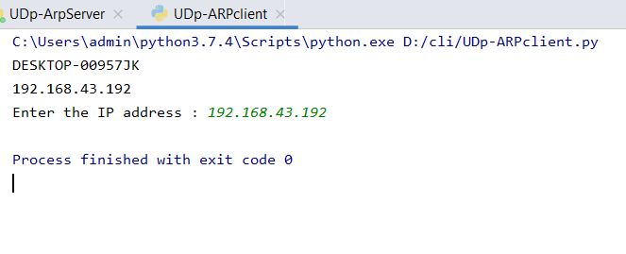Client Console

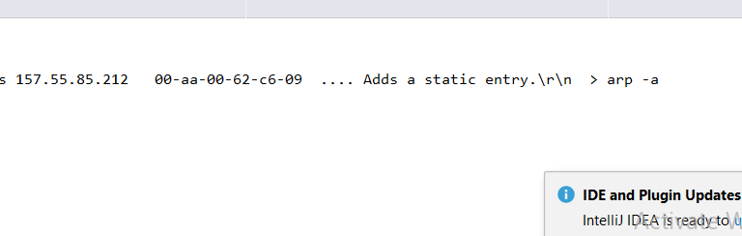Server Console

Result : - ARP implementation using UDP protocol was successfully done.